Statutory Change Alert

Lithuania – Changes in Minimum wages, Tax rates – 1st January 2026


LITHUANIA

We help you achieve your global ambitions

Thank you for trusting Mercans to outsource your HR and Payroll functions. We propose HR consulting services, actionable solutions, and cost-effective global payroll processing tools to energize your human capital management in real-time and augment your performance. We are dedicated to becoming your business growth facilitator.

 | Global Payroll Solutions – Boost your HR brand and employee satisfaction  Rationalize your HR budgets, monitor your data, and optimize your global payroll tasks in real-time. Systematize processes and streamline HRM lifecycles with HR Blizz™, our unified SaaS platform, to ensure your employees are paid accurately and on time.
 | PEO/GEO Services – Easily hire, deploy and manage your workforce abroad  A reliable Professional Employer Organization (PEO), Mercans is your trusted employer of record to globally select, engage, and manage highly qualified personnel on your behalf, through integrated Global Employment Outsourcing (GEO).
 | Global Talent Acquisition – Quickly fill vacancies with only the best candidates  Mercans supports you in designing/deploying long-term HR strategies and processing full-cycle recruitment. Our ATS Suite Mesaar™ and our hiring experts help to screen, select, attract the right candidates for your organization and populate your pipeline of prequalified talents.
 | BPO Services – Reclaim the focus on your core activities to expand your business  Concentrate on the essentials: outsource non-primary activities and your front- and back-office functions to Mercans. Save the time, money, and energy needed to refine the value chain engagement of your customers and suppliers and increase revenue.
 | HR Management SaaS – Access customizable cloud-based online platforms  Centralize your HR function on an all-in-one user-friendly and self-service platform. Combined with the expertise of our consultants, the Mesaar SaaS offers a built-in applicant tracking system and easy-integration features to improve internal processes.
 | Local Statutory Compliance – Forget the hassle of setting up branches abroad  Mercans seasoned HR advisory team are compliance experts specialized in local cultures, business protocols, and tax and legal specificities. They are committed to ensure quick go-to-market abroad and achieve a compliant global expansion, risk-free from A to Z.

Mercans at a Glance

160+  Countries | 20  Years of Success | 1K+  Payroll and HR Specialists
22k+  Clients Worldwide | 97%  Client Retention Rate | 1.5X  Annual Revenue Growth
95k+  Largest Single Country Payroll | 25M+  Pay Slips per Annum | 0  Security Breaches

Number one for outsourced payroll services, we are endorsed by international authorities.

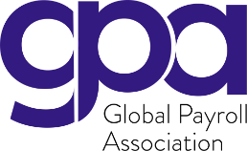 | 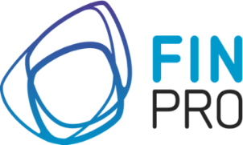 | 


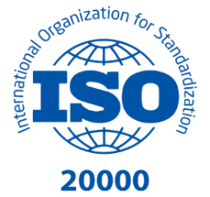
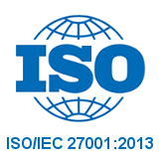
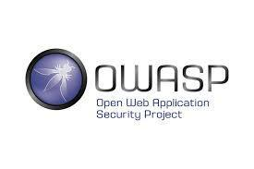
Mercans has the highest industry quality and IT security certificate certificate

Lithuania - Changes in Tax Rates & Minimum Wages - 1st January 2026

Tax rates

Starting January 1, 2026, Lithuania is moving to a more progressive PIT system. The main PIT rates on employment and similar income will change from a two-bracket structure (20%/32%) to a three-bracket structure
Annual Tax table
Income Bracket | Tax rate
Below 82 962 | 0%
Between 82 962 – 138 270 | 25%
138 270 and above | 32%

Note: where an employee has provided a consent, the employer may apply the tax rate of 25%/32% when taxable pay has exceeded €82 962.

The progressive tax rate should be applied in payroll only when an employee provides a request. The most common process is to apply progressive Tax rates submitting Yearly Tax returns. The progressive Tax rates apply not only to Employment income but to the combined annual income.
Minimum Wages
Effective from 1st January 2026: The Minimum wage is € 1153 per month. It is used in the tax exemption amount calculation and employer social security calculation

Tax Exemption Amount of Income (TEAI):

There will be only one TEAI/NPD Formula: € 747 minus 0.49 x (monthly earnings minus minimum wage)
Non-Taxable Income Amount (NPD/NTI):
Starting January 2026, Lithuania is implementing a single, simplified formula for calculating the monthly tax-exempt allowance (Neapmokestinamasis Pajamų Dydis, NPD). The previous formula for higher incomes will be abolished, and the NPD will no longer be granted above a certain income ceiling.
New Monthly NPD Rules for 2026:
- Maximum NPD: If monthly income is less than or equal to €1,153 (the 2026 minimum wage), the NPD remains at €747.
- Tapering NPD: If monthly income is between €1,153 and €2,677.49, the NPD will gradually decrease according to the new single formula.
- Zero NPD: If monthly income exceeds €2,677.49, no NPD will be applied (the tax-exempt amount is zero).
Impact:

These changes mean that employees whose gross monthly salary is above approximately €2,677 will no longer receive any personal tax allowance in 2026, unlike in 2025 when a smaller allowance was still available at higher income levels.
Note: NPD amounts for individuals with reduced capacity for work will remain unchanged (e.g., €1,127 for 0–25% capacity; €1,057 for 30–55% capacity).

Social Security Rates

There is an earning ceiling of €138 270 for the year (2026) when calculating the employees social insurance contribution

Health Insurance base

Health insurance base does not have a ceiling, while social security base has an annual ceiling of €138 270 (2026) from €126 532,80 (2025)

Supplementary Health Insurance Taxation:

Effective January 1, 2026, Lithuania is introducing a new tax-exempt cap for employer-paid voluntary health insurance premiums.

Key Changes:
- New Tax-Exempt Limit: The maximum tax-exempt amount for employer-paid voluntary health insurance premiums will be €350 per year.
- Prior Rule (Before 2026): Previously, employer-paid health or life insurance premiums were generally tax-exempt up to 25% of the employee's annual income.
- Taxation of Excess Amounts: Any premium amount exceeding the €350 annual cap will be treated as the employee's taxable income, subject to Personal Income Tax (PIT) and likely social insurance contributions, similar to salary.
Example:
- If an employer pays €985 per year for an employee's health plan: €350 is tax-free.
- The remaining €635 is added to the employee’s taxable earnings.
- Action Required for Employers:
  - Payroll systems must be updated to ensure PIT is correctly withheld on these excess amounts starting in 2026.

Please contact your Mercans’ services delivery team for any additional information regarding the implications of the above change.

They already trust Mercans

 |  | 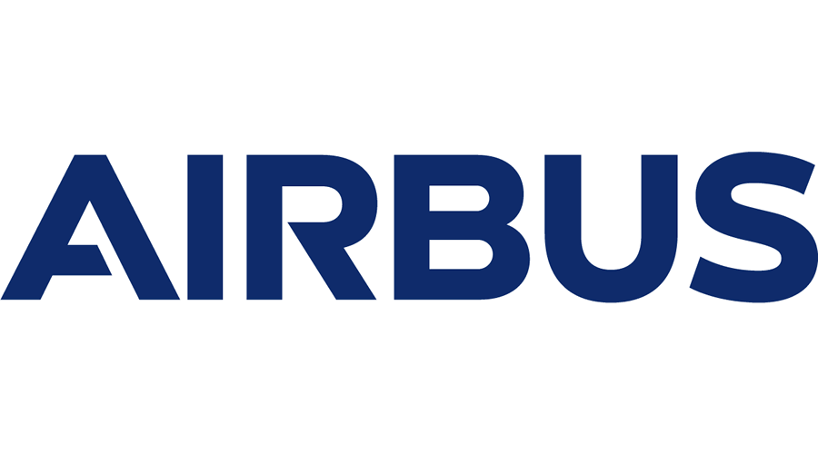 |  | 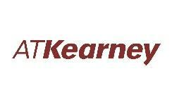
 | 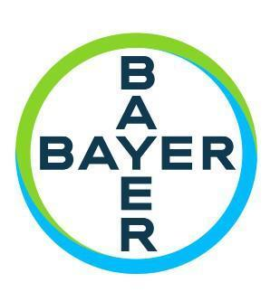 |  | 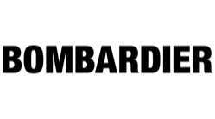 | 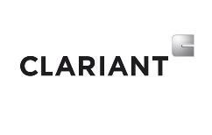
 | 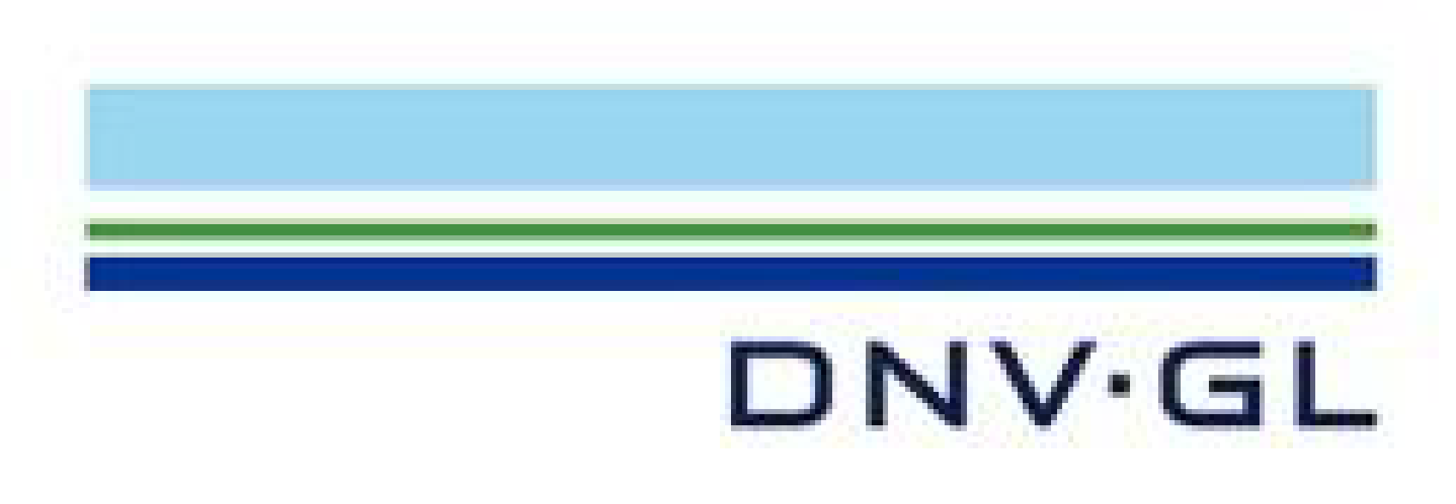 |  | 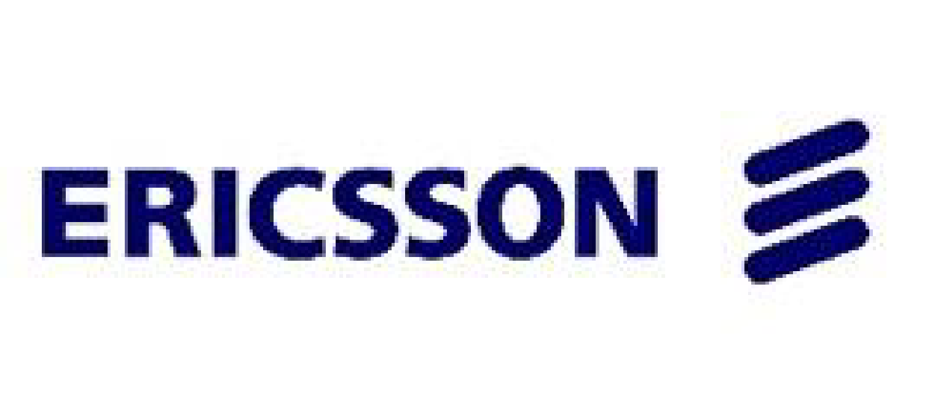 | 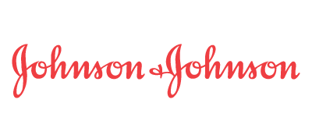
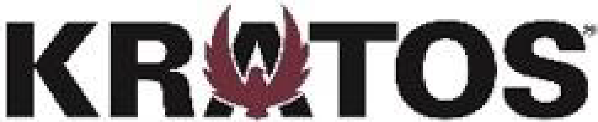 | 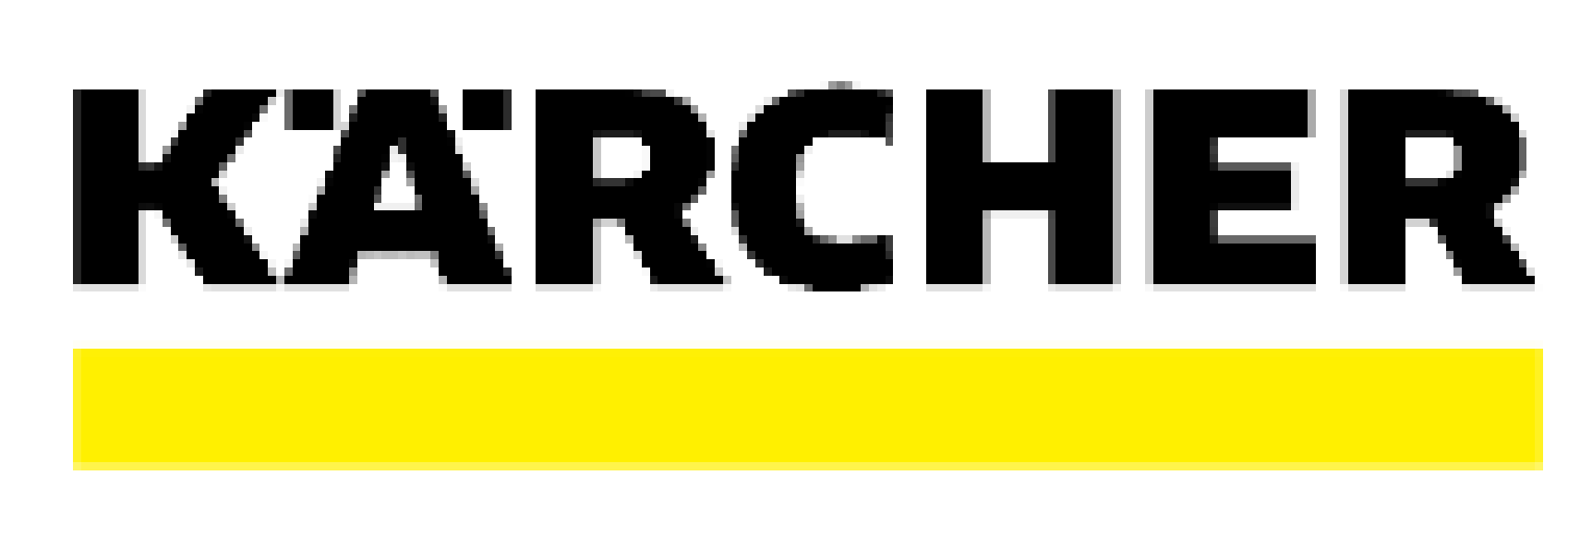 |  | 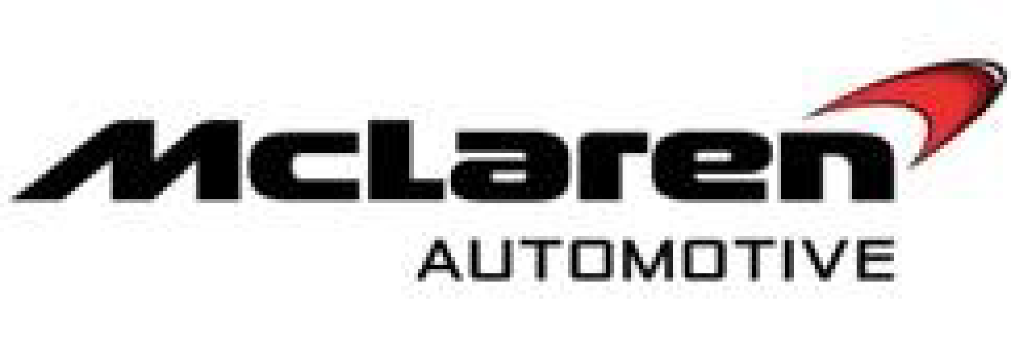 | 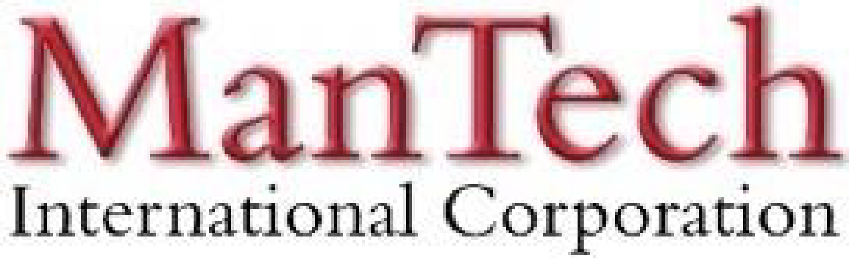
 | 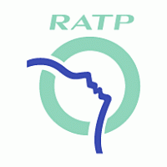 |  |  | 

What Makes Mercans your HR and Payroll Partner of Choice?

We Simplify Employment Tasks Worldwide

Everywhere for Everyone
We are a borderless people engagement enabler, driven by technology and innovation. We deliver bespoke human capital management services and global payroll solutions to empower businesses across 110+ countries regardless of their organizations’ size and their industry. We pride ourselves on being global people experts with a striking local presence, committed to making your teams happy, and ensuring the consistent and sustainable growth of your organization.

Local Presence. Regional Strategy. Global Success
Supported by 500+ payroll and HR specialists with in-depth local knowledge, Mercans operate globally. Our pioneering human resources consulting services and trailblazing SaaS platforms are already satisfying 5,000+ international clients, ensuring timely measurable results and bottom-line savings. Thanks to success-oriented teams striving for excellence and taking care of our clients’ tasks within budget, we have gained the trust of major multinational companies.

A Revolutionary Service Delivery System
Say goodbye to third-party service providers, offshore call centers, fragmented data, and endless chains of sub-contracts.

Mercans cloud-based SaaS Products, HR Blizz™ & Mesaar™, combine the performance of proprietary technologies with a human touch. Cost-effective, they are fully-compliant self-service tools, packed with smart built-in features for your peace of mind. All your data are integrated into single interfaces accessible from everywhere and on any device.

Trailblazing Cloud-Based SaaS Products
HR Blizz & Mesaar, our Software-as-a-Service platforms, both propose a preconfigured API integration capability with all the major global HRMS platforms, including SuccessFactors, Workday, Oracle HCM, and MS Dynamics. All Mercans systems and processes are GDPR compliant, ISO 9001, 20000, 27001 certified, and SOC 1 and SOC 2 audited. A registered Finpro expert, Mercans is also a member of the Global Payroll Association and the Global Payroll Management Institute.

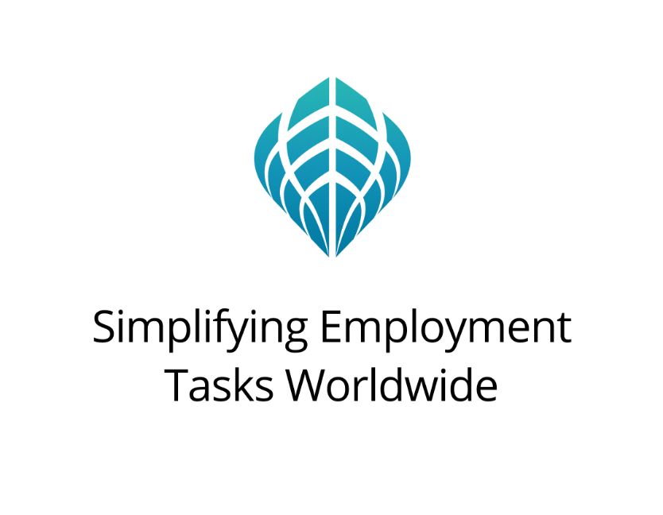

+1 877 MERCANS (637 2267) | Toll-Free
Europe: +44 20 328 777 62
Americas: +1 646 798 5541
Middle East: +971 43 999 260
Asia: +81 50 5539 5354
info@mercans.com | mercans.com

© 2025 Mercans LLC

